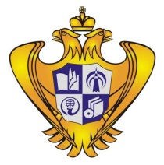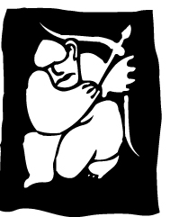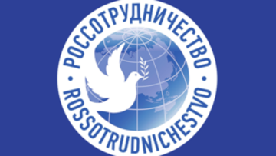

KNJIGE RUSIJE. ČITAMO ZAJEDNO
13 November, Tuesday
14.00- 14.30 - official opening of the Russian stand, main stage, pav. 6.
17.00-17.30 –meeting with children's author Yuri Nechipurenko. Presentation of the Russian festival of children's books and Children's writers Club "Black hen". Presentation of the author's new books about the living cell and Pushkin.
14 November, Wednesday
15.30-16.15 – Presentation of the Russian translation of “Gloria in excelsis" - Miljenko Jergović’s novel.
Speakers: Miljenko Jergović (the author), Larisa Savelyeva (the translator).
16.15-17.00 – Round table "Slavic literature as a factor in mental ecology development in the world”
Participants: writer Miljenko Jergović, translators Larisa Savelyeva and Yulia Sozina, psychotherapist Dmitri Anokhin.
15 November, Thursday
14.30-15.15 – Meeting with poet, translator, literary critic and publisher Maxim Amelin. Presentation of the book "Gorgona's horse" in Croatian.
15.15-16.00 - Meeting with Maxim Osipov, an author of short-stories, plays, and essays. Presentation of collection of his stories “Rock, Paper, Scissors” in Croatian.
16 November, Friday
Program at the Russian stand
17 November, Saturday
15.00-16.00- International projects and grant programmes of the Institute of translation and the Centre of Slavic cultures (Russia).
Speaker: Yulia Sozina
18 November, Sunday
Program at the Russian stand

