Knjige Rusije. Čitamo zajedno.
Russia at Interliber 2018

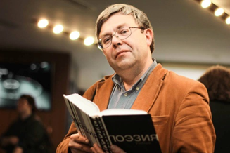
Maxim Amelin
Poet, translator, essayist, researcher, publisher, translator of ancient and modern poetry. Compiled many books of selected works of Russian poets of the late XVIII — early XX century, anthologies of contemporary Russian and Georgian poetry. The laureate of many literary prizes, including the Bunin Prize, Alexander Solzhenitsyn's Literary Prize, and the Poet National Prize 2017.

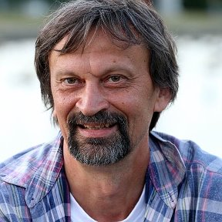
Yuri Nechipurenko
Children’s writer, critic, culturologist, bio-physicist, doctor of physical and mathematical sciences. Nikolay Gogol, Michail Lomonosov and Gaito Gazdanov researcher. His book ““Publican. Father's stories” was translated into Croatian in ELITECH-EDICIJE BOŽIČEVIĆ in 2012.
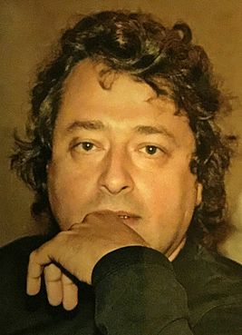

Maxim Osipov
He was born in Moscow in 1953 and trained as a doctor, before emigrating to California in the early 1990s, where he spent two years. In 2005, he quit his successful medical practice and went to work as a cardiologist at a clinic in Tarusa, a small town in the Kaluga Region. Alongside his work as a provincial doctor, Osipov also writes plays, short stories and novels, which has won him the nickname “the new Chekhov.” It is a neat comparison, but is perhaps not that accurate. His prose works include A Sin to Complain (2009) and In the Waves of the Sea (2014). His novel “Kamen, škare, papir ” was published in Croatian in 2018, Hrvatsko filološko društvo, ‬Zagreb.

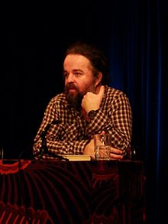
Miljenko Jergović (born. 1964)
Croatian and Bosnian writer, poet and journalist, laureate of national and international awards. Author of numerous short stories, novels and plays that have been translated to more than two dozens of languages. His prose doesn’t have any borders. It belongs to the whole world. Being right at the heart of tragic events, his characters never stop asking eternal questions and paving their own way to the truth.
Column author in “Juternji list”.

Larisa Savelyeva
Born: 26.03.1946, Leningrad. Lives in Moscow since 1955.
Education: Lomonosov Moscow State University, Faculty of Philology. Major: Slavic Philology (graduated in 1972). From 1972 to 1995 – teacher of the Serbian language at Moscow State Institute of International relations.
Member of: Union of Translators of Russia and Association of literary translators, Laureate of literary awards: “Foreign literature” journal’s award (1997), Serbian PEN (2003), “Ugra” international literary award (2013).
Dmitri Anokhin
Born 06.10.1957 in Novosibirsk. Graduate of Novosibirsk medical university (1980). Neurologist, psychotherapist and psychologist of the highest qualification. Member of Professional psychotherapeutical league (from 2008). Author of numerous rehabilitation programmes, including the ones developed for the Centre of Slavic cultures, aiming to promote the concept of mental ecology.

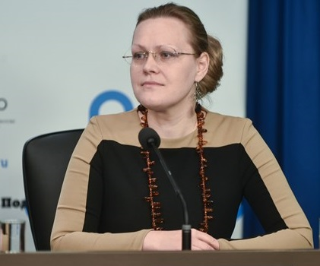
Yulia Sozina (born 1973)
PhD in Philology, Head of the Centre of Slavic cultures, member of the Programme Council of the Forum of Slavic cultures. Research fellow of the Institute of Slavic Studies of the Russian Academy of Sciences.
Editor, translator, author of numerous scientific papers on cultural links between Russia and other Slavic countries, coordinator of “One hundred Slavic novels” project in Russia.
Laureate of “Ugra” international literary award and Dositej Obradović award.

